**FORMAL REPORT ON THE FINDINGS OF USED CAR ANALYSIS.**

This report provides key insights from the analysis of the used car market, highlighting trends and patterns in pricing, fuel type, transmission preferences, brand dominance, mileage impact, location-based pricing, and seating capacity. These findings can guide strategic decision-making and identify areas for further investigation to optimize market strategies.

**METHODOLOGY USED:**

**1. Data Collection and Cleaning:**

I started by downloading the dataset using a link provided on cargo.com. After obtaining the data, I uploaded it into Power BI and performed data cleaning. This involved applying filters to remove irrelevant or inconsistent data.

**2. Data Aggregation:**

Next, I focused on data aggregation. I identified key metrics in the dataset, such as price trends, transmission types, fuel types, and geographical locations. These metrics helped shape the foundation of the analysis.

**3. Data Visualization:**

For visualization, I utilized various chart types, including bar charts, line charts, pie charts, and grid charts, to uncover insights. Additionally, I incorporated interactive filters to allow dynamic exploration of the data, such as filtering by car names, locations, using the top 5 filter.

4. DASHBOARD:

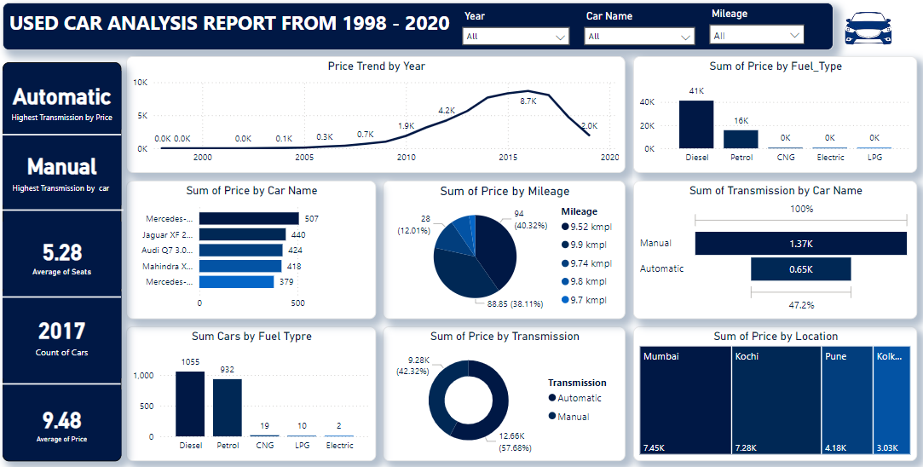

**KEY FINDINGS:**

1. Price Trend Over Time:

The analysis reveals a significant increase in the average price of used cars over time. Cars manufactured between 1996-1998 recorded the lowest prices, while 2016 models commanded the highest average price of 8.6k. This trend underscores the depreciation value associated with older cars.

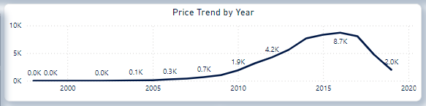

2. Price by Fuel Type:

Diesel cars dominate the used car market, with a total count of 1,055 units, compared to 932 petrol cars. Alternative fuel types, including CNG, LPG, and Electric, represent a negligible share. This suggests a strong preference for diesel-powered vehicles, likely due to their fuel efficiency and longer lifespan.

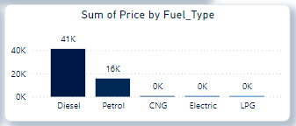

3. Price by Transmission:

Manual transmission vehicles hold a majority share of 57.68%, while automatic cars contribute 42.32%. However, automatic transmission vehicles exhibit higher average prices, reflecting their premium positioning and growing consumer preference for convenience.

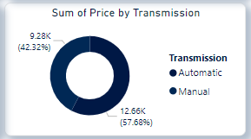

4. Price by Car Name:

Luxury brands like Mercedes-Benz, Jaguar, and Audi dominate the high-price segment. Mercedes-Benz, in particular, has the highest price contribution, indicating its widespread use and strong brand value within the used car market.

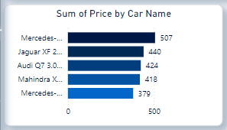

5. Price by Mileage Relationship:

Cars with higher mileage figures, such as 9.8 kmpl, 9.7 kmpl, and 9.74 kmpl, are associated with lower prices. Conversely, vehicles offering superior mileage tend to command premium pricing, emphasizing the importance of fuel efficiency in consumer purchasing decisions.

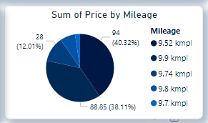

6. Price by Location:

Mumbai leads in average used car prices at 7.45k, followed by Kochi at 7.25k. In contrast, Pune and Kolkata have significantly lower averages of 4.18k and 3.03k, respectively. These variations highlight the influence of regional economic conditions and consumer demand on pricing.

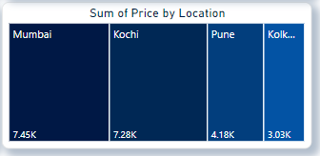

7. Seating Capacity

The average seating capacity across the analyzed vehicles is 5.28, a figure typical for sedans and SUVs. This indicates limited representation of smaller cars or larger passenger vehicles in the dataset.

**How These Insights Can Help in Decision Making:**

1. **Pricing Strategy**:
   * Sellers can leverage insights into price trends to set competitive prices for their vehicles, especially focusing on newer models or those with higher fuel efficiency.
   * Buyers can use this data to negotiate prices, particularly for older or high-mileage vehicles.
2. **Inventory Management**:
   * Dealers might consider prioritizing diesel and manual transmission vehicles in their inventory, as these dominate the market. However, they should also stock some automatic cars to cater to the growing demand for convenience.
3. **Targeted Marketing**:
   * Luxury brands and high-price segment vehicles could be marketed toward affluent consumers or regions like Mumbai and Kochi, where average prices are higher.
   * Promotions for fuel-efficient cars could appeal to cost-conscious buyers.
4. **Location-Based Pricing**:
   * Dealers and sellers can adjust pricing strategies based on regional demand, ensuring alignment with local economic conditions and consumer expectations.
5. **Product Offering**:
   * Insights on seating capacity can help manufacturers or sellers understand market preferences, focusing on 5-seater sedans and SUVs which dominate the dataset.
6. **Brand Positioning**:
   * High-price dominance by brands like Mercedes-Benz, Jaguar, and Audi suggests the need for maintaining or enhancing their luxury appeal through marketing and after-sales services.
7. **Mileage Emphasis**:
   * Highlighting mileage as a key feature in marketing efforts can influence purchasing decisions, especially for fuel-efficient models.

**Areas for Further Investigation:**

1. **Regional Demand Drivers**:
   * Investigate why cities like Mumbai and Kochi exhibit higher

Average prices. Are these differences due to purchasing power, urban density, or other factors?

1. **Changing Preferences**:
   * Examine trends in the growing popularity of automatic cars. What factors (e.g., urban congestion, technological advancements) are driving this shift?
2. **Fuel Type Evolution**:
   * Explore why alternative fuel vehicles have a negligible market share. Are there barriers like infrastructure, cost, or consumer perception?
3. **Brand Loyalty and Retention**:
   * Study consumer loyalty for high-price brands to understand repeat purchases or upgrades within luxury segments.
4. **Mileage Trends**:
   * Analyze if mileage preferences are shifting over time, potentially driven by rising fuel costs or environmental consciousness.
5. **Depreciation Factors**:
   * Investigate factors beyond age that influence car depreciation, such as brand reliability, maintenance costs, or model-specific issues.
6. **Seating Capacity and Vehicle Types**:
   * Explore the representation of smaller cars and larger passenger vehicles. Is there an untapped demand for these categories in specific regions or use cases?